Garden fence algorithm worksheet

From a problem to a pseudocode algorithm

The problem

Maria wishes to put up a fence around her garden. Her garden has a width **gardenwidth** metres and a length **gardenlength** metres. She has chosen the fence panels she wants to use which are height **fenceh** metres and width **fencew** metres.

The task is to write a pseudocode algorithm that would calculate how many fence panels she will need.

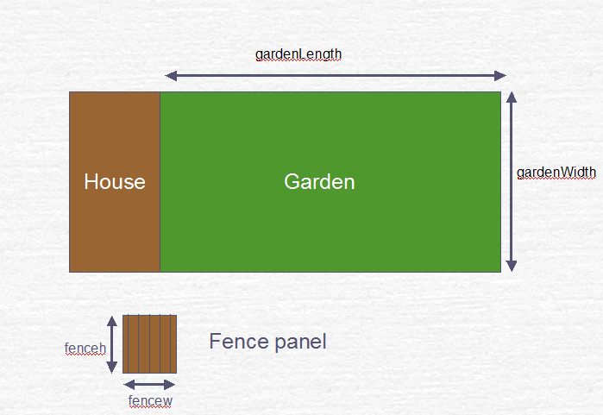

Step One: Decide on the inputs

There are four different variables mentioned in the problem. You will only need three of them. Write down the **Identifier** of three variables from the problem you will need the user to input.



Step Two: Decide on the outputs

Write down an **Identifier** for what you will need to output to the user. names.

Outputs:

Step Three: Decide on the calculations needed (processing)

You will need at least two different calculations to solve this problem. Write down what they will be.

HINT: You may find it useful to know about DIV (integer division). DIV gives the whole number part of any division. For example, 16 DIV 5 gives 3 and 17 DIV 5 also gives 3. MOD is another operator you can use which gives the remainder after integer division. For example, 16 MOD 5 will be 1 and 17 MOD 5 will be 2.

1

2

3

Step Four: Write out in order and in pseudocode

**Complete algorithm:**

##### Extension

Maria decides that she will paint the fence panels blue. One tin of outdoor fence paint will cover paint area metres2. She wants to paint both sides of the fence panels.

Add to your pseudocode algorithm the necessary statements to calculate the number of tins of paint needed.

Extension to algorithm: